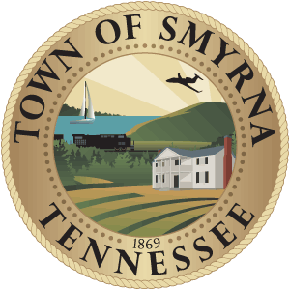

SMYRNA CHARITY ASSISTANCE FUND BOARD
April 13, 2023
Smyrna Town Hall
5:00 p.m. meeting

AGENDA
- Call to Order
- Prayer and Pledge of Allegiance
- Approval or Correction of Minutes of November 2022 meeting
- Old Business
  - Fund Balance
- New Business
  - Introduction of new board members
  - Selection of a co-chair
  - Meeting Calendar for 2023
  - Discuss revisions to application.
- Staff Comments and/or Other Business
- Adjournment

